Lecture 15

**Yum-Deep dive**

Yum

Yellowdog updater, modifier

* To install packages related RPM package manager
* $ yum install <package_name>
* Or
* Yum update <package_name> 🡪 to update already installed software
* We r to learn 🡪 how yum goes to internet and installs the package
* $ yum install dovecot
  + Yum works same wha 🡪 It installs through “rpm” command
  + It downloads the required package and dependencies from repository

How yum works

* 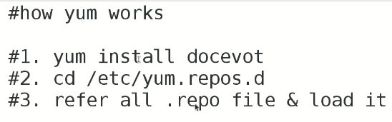
* “.repo” file contains url of the particular package
* 🡪 this action is performed on “.repo” file.
* 
* Look into the yum.repo.d directory
* 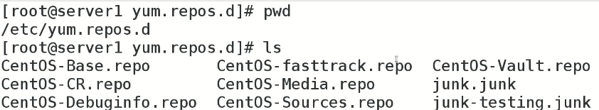
* “base.repo” contains related url which are used to go to internet for downloading specific package
* “base.repo” contains –> baseurl and mirror list,
* 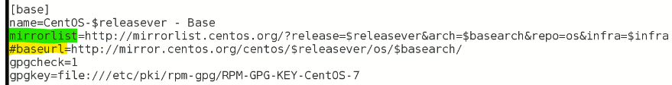
* “yum” selects the fastest mirror to download the package
* There r many repos 🡪 which one to be loaded???
* 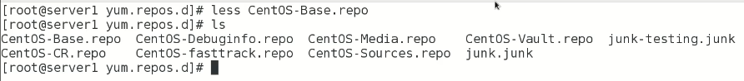
* The fastest one
* These all repo files are checked to get required url
* 
* 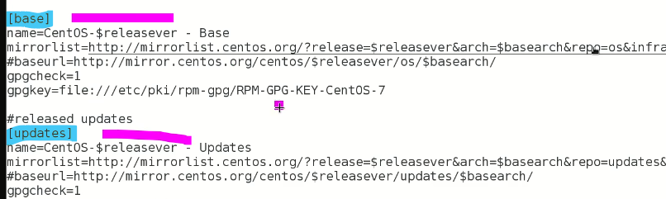
* [base] and [updates] are called tags
  + Contains baseurl and mirrorlist
  + mirrorlist.centos.org 🡪 is just like DVD or a directory which contains different rpm packages.
  + Yum first checks inventory book 🡪 it finds “required package” listed in inventory book, and its all dependencies 🡪
  + 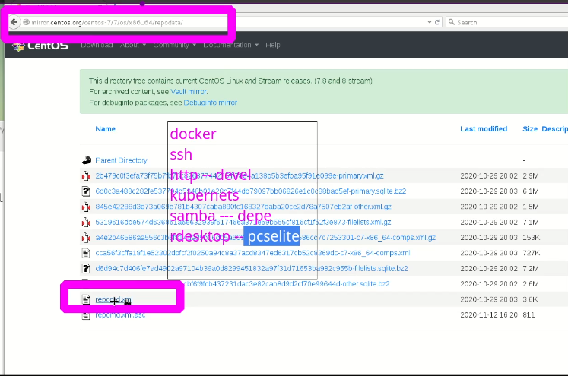
* Steps of yum process
* 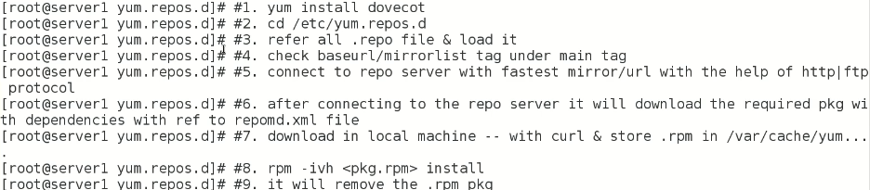
* If error occur 🡪 check dns setting 🡪 or http port is not opened in firewall
* Try “pkill yum” if yum is struck and restart it
* By default “rpm downloaded” packages are downloaded in 🡪 $ /var/cache/yum/x86_64/7/base
* 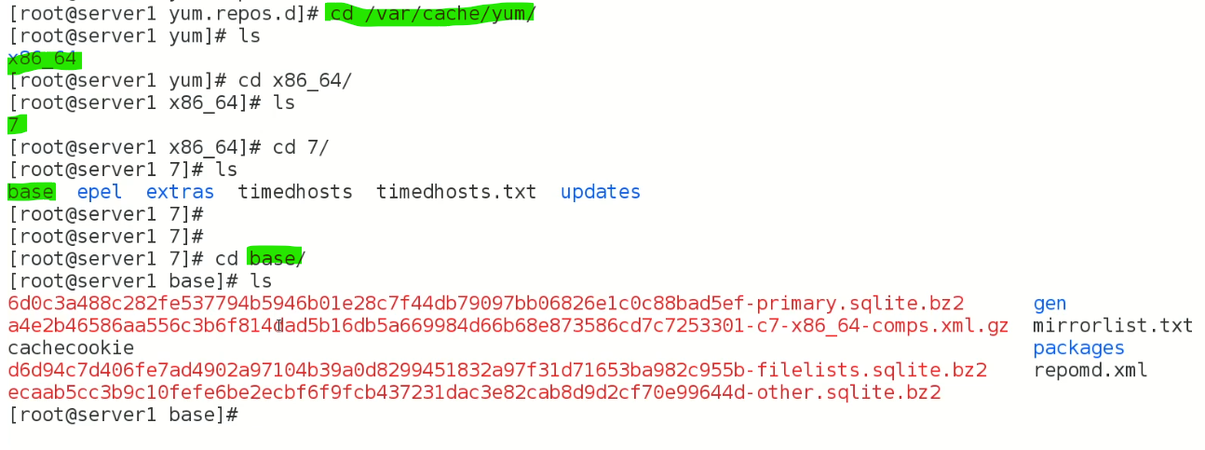
* In /packages

But the package will be automatically removed after installation.

* If “yum” is not working properly 🡪 $ yum clean all 🡪 clears cache
* Tip: $ yum search <package_name> to search for a specific package in repositories
* $ yum list <package_name> 🡪 to search everywhere on internet.
* The package can be verified, by
* Verify the package: If possible, verify the digital signature of the package to ensure that it has not been tampered with. You can use the "rpm" command with the "--checksig" option to verify the package's signature.
* $ rpm - -checksig <packahe_name>.rpm
* There is another repository for extral packages,
* 
* So “epel” repository is to be installed,
* $ yum install epel
* 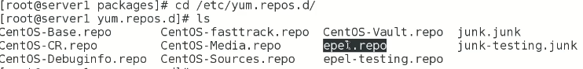
* Few available repositories online
* 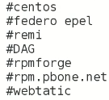

RPM packages can be found in various repositories, some popular ones include:

* Fedora RPMs: The official repository for Fedora, a Linux distribution.
* EPEL (Extra Packages for Enterprise Linux): A community-driven repository that provides additional packages for Enterprise Linux distributions such as RHEL, CentOS, and Scientific Linux.
* Nux Dextop: A third-party repository that provides additional RPM packages for Fedora and Enterprise Linux distributions.
* Remi Repository: A third-party repository that provides updated versions of packages for Fedora and Enterprise Linux distributions.
* OpenSUSE Build Service: A build service that provides RPM packages for multiple Linux distributions.

$ yum - -enablerepo=epel install <package_name> 🡪 it will only look for “epel” repo only and install required package

* To define priority of available repos
* in CentOS 7 $ yum install yum-priorities
* The yum-priority plugin is a plugin for the YUM package manager that provides the ability to set priorities for packages from different repositories. With this plugin, you can specify which repositories should have priority over others, which can be useful if you have multiple repositories enabled and want to control which packages are installed from which repository. This can be especially useful in cases where multiple repositories provide the same package, and you want to ensure that a specific version is installed. By specifying the priority, you can control which repository YUM will use to install packages.
* Installation,

The steps to install the yum-priority plugin depend on the Linux distribution you are using. Below is an example for a Red Hat Enterprise Linux (RHEL) or CentOS system:

* Check if the plugin is already installed: You can check if the yum-priority plugin is already installed by running the command "yum list yum-plugin-priorities". If the plugin is installed, you will see it in the list of available packages.
* Install the yum-utils package: If the yum-priority plugin is not already installed, you will need to install the yum-utils package, which provides a number of useful plugins for YUM, including the yum-priority plugin. You can install yum-utils by running the command: "sudo yum install yum-utils".
* Enable the plugin: Once the yum-utils package is installed, you will need to enable the yum-priority plugin. You can do this by editing the YUM configuration file located at "/etc/yum/pluginconf.d/priorities.conf" and setting the "enabled" option to "1". You can use a text editor like nano to edit the file: "sudo nano /etc/yum/pluginconf.d/priorities.conf".
* Verify the plugin is working: After enabling the yum-priority plugin, you can verify it is working by running the command "yum repolist". This will display a list of enabled repositories and show the priority of each repository.
* Set the priority of repositories: You can set the priority of repositories by adding a "priority" option to each repository in the "/etc/yum.repos.d/" directory. The higher the number, the higher the priority. For example, if you want to set a repository named "repo1" to have priority over a repository named "repo2", you would add the following line to the "repo1.repo" file: "priority=1" and to the "repo2.repo" file: "priority=2".
* Suppose priority of “epel” is needed to be changed 🡪 open its repo file
* 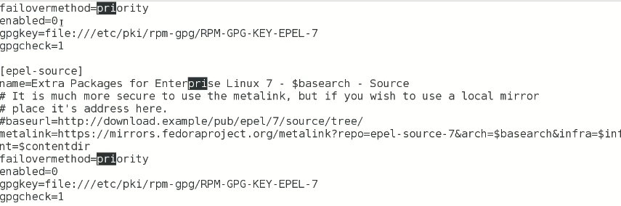
* Here change the 0 with 1 🡪 to set the priority.
* Task,
* Add an additional “repository” 🡪 epel
* Yum should not work 8 to 10 ways (interview question)
* 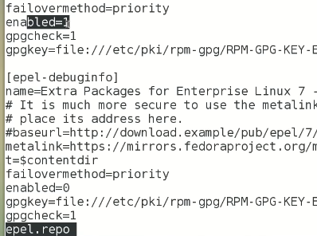
* If firewall is restricting internet access

Yum offline can be used (interview question)

For this purpose local repository server is to be established

* Diagram

  Description automatically generated
* 